Vietnam General Confederation of Labor
TON DUC THANG UNIVERSITY
FACULTY OF INFORMATION TECHNOLOGY


FINAL REPORT
MANAGEMENT OF INFORMATION SYSTEM

Instructor: Mrs. HO THI THANH TUYEN
Student: PHAN THANH DAT – 521H0218
LE MINH ANH - 521H0004
PHAM TRAN TIEN PHAT - 521H0285
Class: 21H50302 - 21H50201
Year : 25

HO CHI MINH CITY, 2024
Vietnam General Confederation of Labor
TON DUC THANG UNIVERSITY
FACULTY OF INFORMATION TECHNOLOGY


FINAL REPORT
MANAGEMENT OF INFORMATION SYSTEM

Instructor: Mrs. HO THI THANH TUYEN
Student: PHAN THANH DAT – 521H0218
LE MINH ANH - 521H0004
PHAM TRAN TIEN PHAT- 521H0285
Class: 21H50302 - 21H50201
Year : 25

HO CHI MINH CITY, 2024

ACKNOWLEDGEMENT
We would like to thank Ton Duc Thang University, Faculty of Information Technology for including this subject in the training chart of Software Engineering and for creating the best learning conditions for we as well as all students of the faculty. Our report is a product of what we have learned in the semester.
We would like to thank Professor Tuyen for her patience, encouragement, and inspirational teaching style, which has inspired us to pursue excellence in the field of Enterprise Resource Planning.
Thank you, Mrs. Ho Thi Thanh Tuyen, for your exceptional mentorship and dedication to our academic development.
Finally, we wish you good health and success in your noble career.

Ho Chi Minh city, 12th May, 2024
Author
(Sign and write full name)

Phan Thanh Dat

Le Minh Anh

Pham Tran Tien Phat
THIS PROJECT WAS COMPLETED AT
TON DUC THANG UNIVERSIY
We fully declare that this is our own project and is guided by Mrs. Ho Thi Thanh Tuyen; The research contents and results in this topic are honest and have not been published in any form before. The data in the tables for analysis, comments and evaluation are collected by the author himself from different sources, clearly stated in the reference section.
Besides that, the project also uses a number of comments, assessments as well as data from other authors, other agencies and organizations, with citations and source annotations.
Should any frauds were found, we will take full responsibility for the content of our report. Ton Duc Thang University is not related to copyright and copyright violations caused by me during the implementation process (if any).

Ho Chi Minh city, 12th May, 2024
Author
(Sign and write full name)

Phan Thanh Dat

Le Minh Anh

Pham Tran Tien Phat

CONFIRMATION AND ASSESSMENT SECTION
Instructor confirmation section
_______________________________________________________________________________________________________________________________________________________________________________________________________________________________________________________________________________________________________________________________________________________________________________________________________________
Ho Chi Minh May, 2024
(Sign and write full name)

Evaluation section for grading instructor
_______________________________________________________________________________________________________________________________________________________________________________________________________________________________________________________________________________________________________________________________________________________________________________________________________________
Ho Chi Minh May 2024
(Sign and write full name)

SUMMARY
This is a report on the Management Information System of the Faculty of Information Technology, Ton Duc Thang University. It provides an analytical report on the information systems of a fictitious business. In this report, our team analyzed the information system of a hotel. We analyzed the structure of the hotel industry in Vietnam, from which we proposed campaigns for the next 10 years. In addition, we analyzed the existing problems in the hotel's information system and found new solutions for the system.

TABLE OF CONTENT
ACKNOWLEDGEMENT i
CONFIRMATION AND ASSESSMENT SECTION iii
SUMMARY iv
TABLE OF CONTENT 1
TABLE OF FIGURE 5
CHAPTER 1 – BUSSINESS DESCRIPTION 7
1.1 Introduction. 7
1.2 Objectives. 7
1.3 Mission. 7
1.4 Size. 7
1.5 Organization chart. 8
CHAPTER 2: ANALYZE EXISTING INFORMATION SYSTEM. 9
2.1 Industry Structure. 9
2.1.1 Overview of the Hotel Industry Market in Ho Chi Minh City. 11
2.1.2 Target market share. 12
2.2 Competitive forces. 13
2.2.1 Traditional competitors. 13
2.2.2 New market entrants. 14
2.2.3 Power of suppliers. 15
2.2.4 Power of customers. 16
2.2.5 Threat of substitutes. 16
2.3 Competitive advantage. 18
2.4 Competitive Strategy. 18
2.5 Value Chain. 20
2.5.1 Main activities. 20
2.5.2 Support Activities. 21
2.6 Information Structure. 22
CHAPTER 3: ORGANIZATION ISSUES. 24
3.1 Low-quality fire alarm system. 24
3.2 Website not yet developed. 25
3.3 Energy wastage. 26
CHAPTER 4: PROPOSAL OF A NEW SYSTEM. 29
4.1 Use case diagrams. 29
4.2 ERD. 30
4.3 Improved technique. 31
4.4 Analyze the improvement. 33
4.5 Identify ethical and privacy issues. 35
CHAPTER 5: DEMO. 37
5.1 Website. 37
5.2 Fire alarm system. 38
CHAPTER 6: EVALUATION, CONCLUSION. 40
6.1 Pros and Cons. 40
6.2 Our Reviews. 41
6.3 Lessons learned from the project. 41
6.4 Evaluate group activities. 42
CHAPTER 7: SELF - EVALUATION FORM 43
REFERENCES 45

TABLE OF FIGURE

Figure 1. 1 Organization chart of hotels 5

Figure 2. 1 International visitors by month in 2022 (thousand arrivals) 6

Figure 2. 2 Statistics of the tourism industry on 5 continents 7

Figure 2. 3 Hotel Vietnam's market 8

Figure 2. 4 Statistics of tourists coming to Vietnam in 2019 9

Figure 2. 5 Rex Hotel 10

Figure 2. 6 New World Saigon Hotel 11

Figure 2. 7 OTAs 11

Figure 2. 8 Alternative Accommodation Platforms 12

Figure 2. 9 Boutique 12

Figure 2. 10 Apartment 14

Figure 2. 11 Airbnb- Vacation rental company 14

Figure 2. 12 Resort 15

Figure 2. 13 Competitive strategy period in 10 years 16

Figure 4. 1 Use case diagrams of fire alarm systems. 26

Figure 4. 2 Use case diagrams of hotel website 27

Figure 4. 3 Use case diagram of energy systems 27

Figure 4. 4 ERD of Hotel 28

Figure 5. 1 Interface of hotel website 35

Figure 5. 2 Interface of booking hotels website 36

Figure 5. 3 Fire alarm system 36

Table 4. 1 Table of the improvement 33

CHAPTER 1 – BUSSINESS DESCRIPTION

1.1 Introduction.
“Prestige Imperial” is a hotel that is not too sought after in the restaurant and hotel industry, located in the center of the city. Ho Chi Minh city with an immersive view of the sky, and urban landscape at night. With modern architecture coupled with sophisticated design, the hotel provides a classy living space and experience, where all customers can relax and enjoy a good life.

1.2 Objectives.
To become a leading destination in the tourism and accommodation industry, not only with excellent service quality but also with unique creativity and amenities. Our top goal is to provide a smart and comfortable living environment, where customers can fully enjoy every moment, from booking to check-out.
With the aspiration to not only make a deep impression on service quality but also create its own brand that is luxurious, unique but also somewhat familiar to customers even if it is their first time coming to the hotel. Visitors will feel absolutely satisfied with each service they experience.

1.3 Mission.
Focus on building a smart, impressive, and interactive living space for customers. Committed to providing a perfect stay experience by applying advanced technology such as IoT in hotels, creating a smart and comfortable living environment, where every customer experience is optimized, from the check-in and check-out process to using hotel services and amenities.

1.4 Size.
Rooms: “Prestige Imperial” has a total of 100 rooms, including Family, Deluxe and Suite. Facilities: spa area, gym, infinity pool, restaurant and bar, event conference room and outdoor garden and terrace.

1.5 Organization chart.
The organizational chart of a hotel reservation operation usually includes main departments such as sales, customers, customer care, accounting, and administration. The sales department is responsible for finding and establishing relationships with hotels, booking rooms, and managing advertising and marketing campaigns. The customer service department is responsible for receiving customer booking requests and providing information about hotel services. The customer care department ensures customer satisfaction and handles feedback requests that arise. The accounting and administrative department is responsible for managing the company's finances and administrative operations.

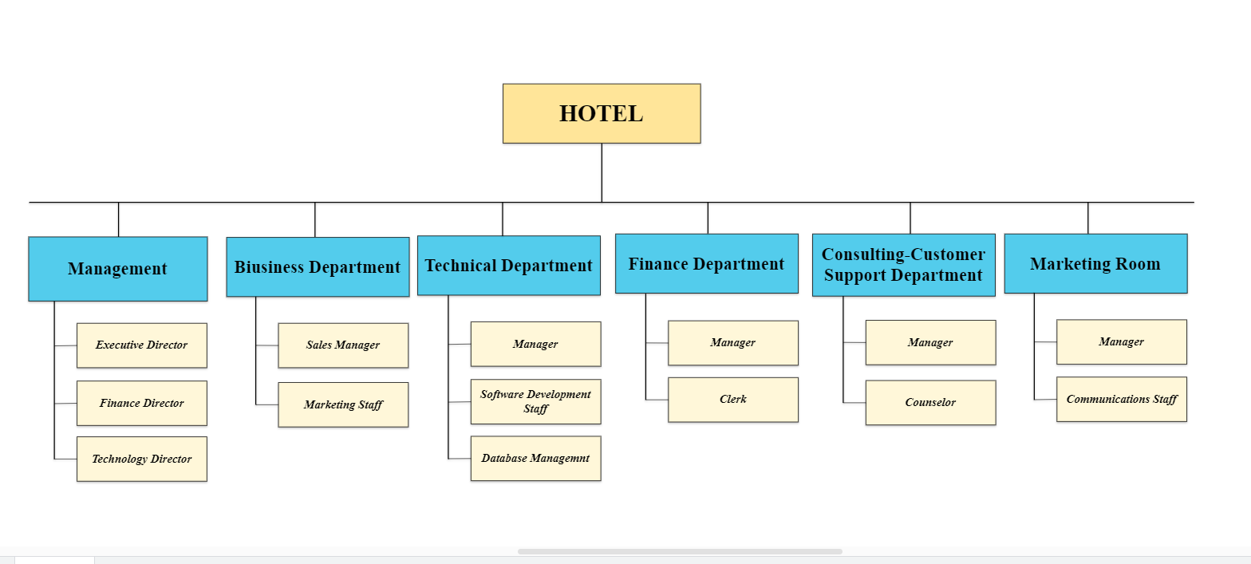
Figure 1. 1 Organization chart of hotels

CHAPTER 2: ANALYZE EXISTING INFORMATION SYSTEM.

2.1 Industry Structure.
The Vietnam hotel market has generated revenue of 2.69 billion USD in the current year and is poised to achieve a CAGR of 14% during the period 2024-2029.
After the Covid-19 pandemic, along with fluctuations in the world economic and political situation, world tourism activities have not recovered as predicted but are happening slowly, especially in Asia. Vietnam tourism has actively implemented many solutions and achieved positive results, making an important contribution to economic recovery after the pandemic. The Vietnam National Administration of Tourism (VNAT) has promoted Vietnamese tourism on digital platforms to target markets and participated in important international tourism fairs to affirm Vietnam as a safe and attractive destination. guided and ready to welcome tourists back after the Covid-19 pandemic.
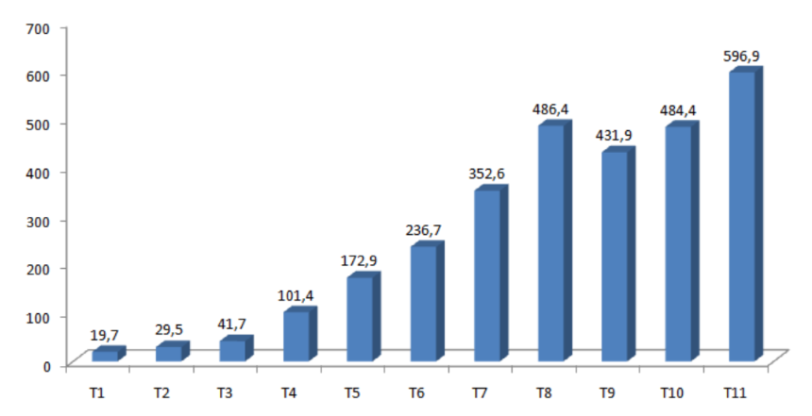
Figure 2. 1 International visitors by month in 2022 (thousand arrivals)
In only the first 11 months of 2022, Vietnam welcomed nearly 3 million international visitors. According to the 2022 report of the World Economic Forum, Vietnam's Travel and Tourism Development Index in 2021 ranked 52nd, up 8 places compared to 2019, ranking in the group of 3 countries with large improvements. best of the world.
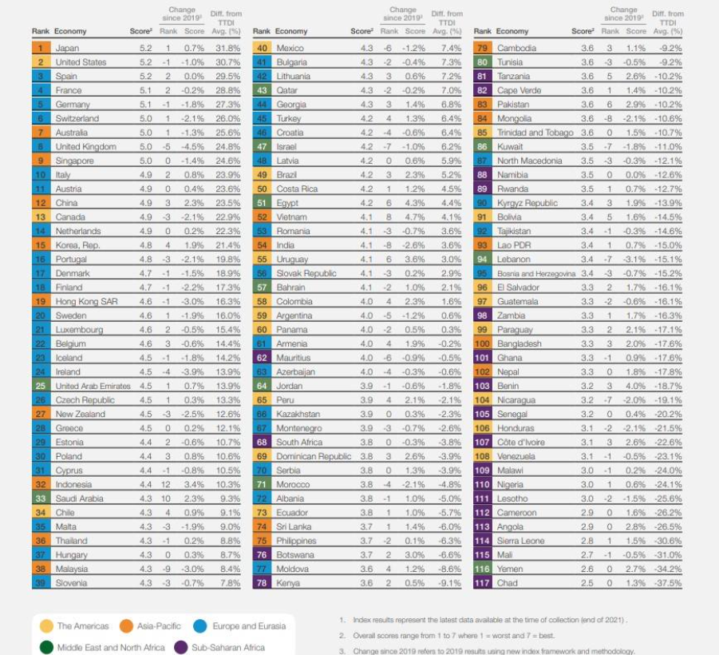
Figure 2. 2 Statistics of the tourism industry on 5 continents
With the sudden increase in the number of tourism industry, the hotel industry in Vietnam has grown continuously in recent years. This has reflected the increase in the weight of international and domestic tourists. The industry will continue to grow, and the majority of hotels/hotel chains are either independent or homegrown. With a rich culture and history, along with famous locations such as Hanoi, Da Nang, Nha Trang and City. Ho Chi Minh.
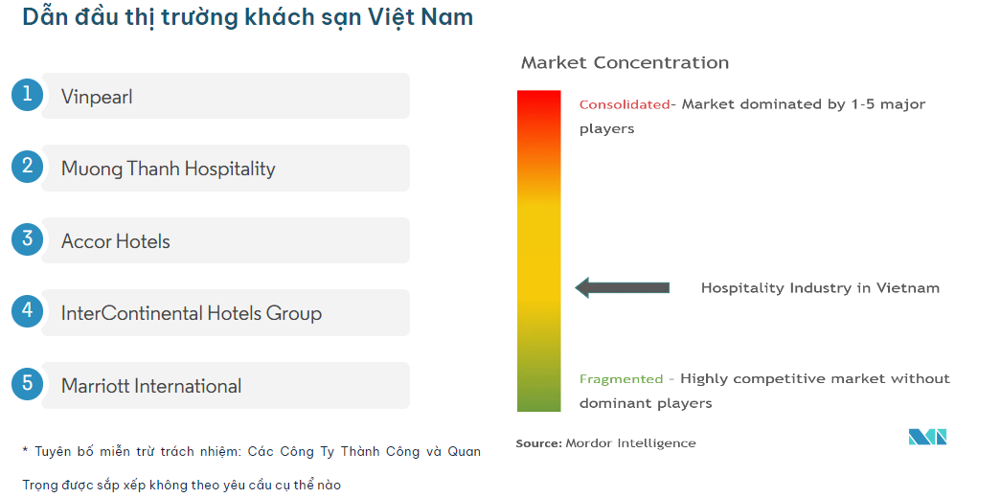
Figure 2. 3 Hotel Vietnam's market

2.1.1 Overview of the Hotel Industry Market in Ho Chi Minh City.
As the most dynamic city in Vietnam, international visitors are the main source of revenue for the 4 - 5-star hotel segment, accounting for 80 - 90% of the total demand market share in Ho Chi Minh City. In 2020, the city welcomed only 1.3 million international visitors (mainly in the first quarter), a sharp decrease of 84.8% over the same period last year. In the first 9 months of 2021, the number of domestic tourists to Ho Chi Minh City continued to decrease by 31% compared to the same period in 2020, with 7.8 million visitors recorded, while international tourists were almost absent.
The average room rental price in 2020 in Ho Chi Minh City reached 91.1% compared to 2019 and room capacity was only 25%, down 43.9 ppt over the same period. Because the epidemic in Ho Chi Minh City was controlled quite well in Q2/2020, tourism demand in general recovered quite slowly. Room rental rates did not improve much in the second half of the year and room occupancy only increased slightly. RevPAR for the whole year 2020 reached 23.9 USD, down 70.9% over the same period last year.
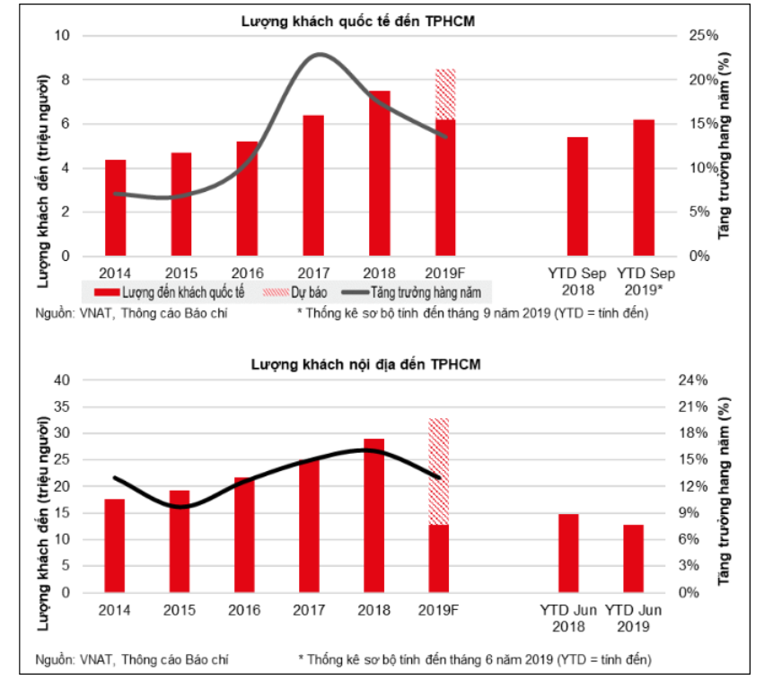
Figure 2. 4 Statistics of tourists coming to Vietnam in 2019

2.1.2 Target market share.
The market share of the hotel industry depends on many factors such as economics, culture, technology, and competition. Based on current trends in the development of the tourism industry, Prestige Imperial wishes to become a breath of fresh air in the hotel market in Vietnam. Previously, Prestige Imperial was not too prominent in the market because it was too outdated and had not updated new trends. With the goal of outstanding development in the next 10 years (2034), Prestige Imperial will capture 15% of the hotel industry's market share by applying IOT technology to the hotel management system.

2.2 Competitive forces.

2.2.1 Traditional competitors.
a) Rex Hotel Saigon.
Rex Hotel has become a 5-star hotel with the quality of services and products always highly appreciated by customers, located right in the heart of the City, on Nguyen Hue Avenue - the largest walking street. Currently. With more than 90 years of establishment and development, Rex Hotel Saigon today is a luxury hotel with 286 bedrooms, 5 restaurants and bars, a system of 8 modernly equipped meeting rooms, and a shopping area with famous brands. world famous, two swimming pools, tennis courts and top health care club.
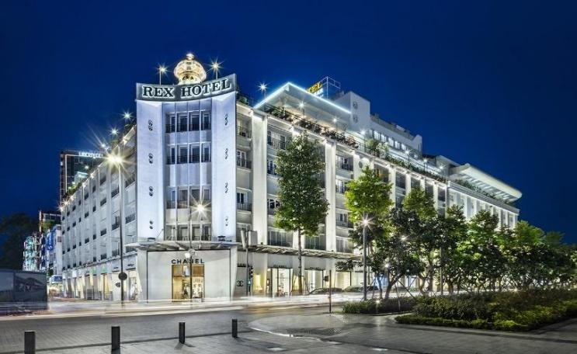
Figure 2. 5 Rex Hotel
b) New World Saigon.
With a history of more than 25 years, New World Saigon is one of the first international standard 5-star hotels in Ho Chi Minh City. Officially put into operation in 1994, experiencing many ups and downs, blending into the flow of times, New World is always in the top of high-end hotels. Located right in the city center, next to September 23 Park and near Ben Thanh market, Fine Arts Museum, Notre Dame Cathedral, Independence Palace... this hotel is always the choice of politicians, businessmen, and tourists. foreign countries when coming to Vietnam. In addition to constantly improving service quality, New World Saigon always focuses on innovating facilities, ensuring a premium experience for visitors.
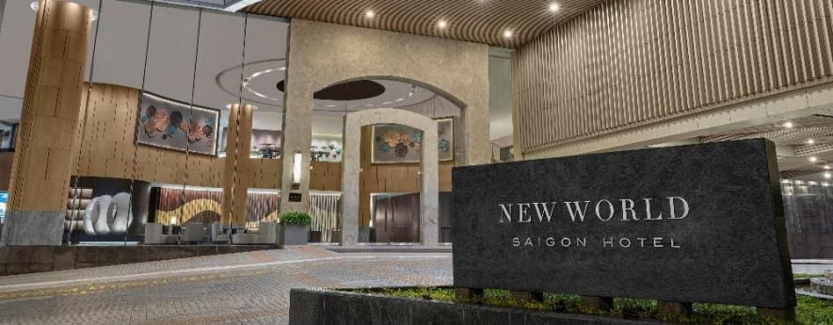
Figure 2. 6 New World Saigon Hotel

2.2.2 New market entrants.
a) Online Travel Agencies - OTAs.
The rise of online booking platforms (OTAs) such as Booking.com, Expedia, and Agoda has fueled the popularity of internet booking. Customers increasingly choose OTAs to search for deals, compare prices and reviews from previous customers, creating a fiercely competitive environment among hotels.
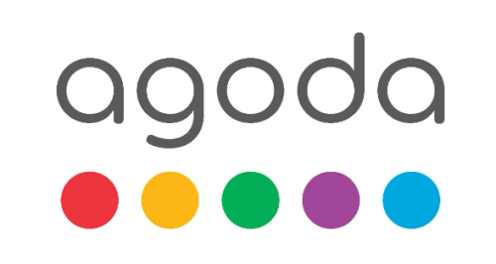

Figure 2. 7 OTAs
b) Alternative Accommodation Platforms.
The emergence of alternative accommodation platforms such as VRBO and HomeAway has opened a new range of accommodation options for customers. These options are often cheaper and offer unique lodging experiences that challenge the existence of traditional hotels.
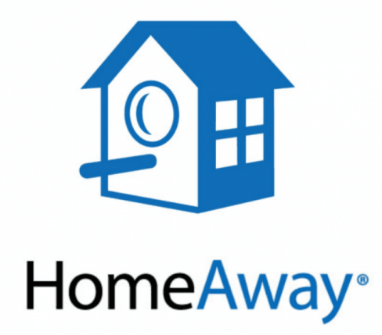
Figure 2. 8 Alternative Accommodation Platforms
c) Boutique and small hotels.
The growth of boutique and boutique hotels has attracted a new segment of customers, looking for a personalized and unique stay experience. These hotels often focus on providing unique services and experiences to customers, creating new challenges for large hotels.
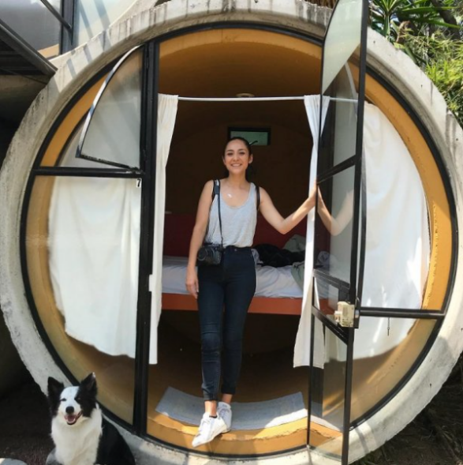
Figure 2. 9 Boutique

2.2.3 Power of suppliers.
In the hotel industry, distributors have important bargaining power to secure their interests and improve business performance. They can negotiate terms of cooperation with hotels, including setting prices, discounts, and marketing and promotional terms. This bargaining power allows them to ensure that their products and services are introduced effectively and to the maximum benefit of both parties. However, they also have to face fierce competition from other distributors and ensure that they do not lose customers or sales due to failed negotiations.

2.2.4 Power of customers.
In the hotel industry, customers have the right to negotiate and request certain conditions of cooperation to ensure their benefits and improve their own experience. They often ask for discounts or rebates when purchasing large quantities of rooms or services, such as booking rooms for a special event. At the same time, they also care about service quality and may ask hotels to provide amenities such as free Wi-Fi, 24/7 room service and entertainment activities.

2.2.5 Threat of substitutes.
a) Serviced Apartment.
Serviced apartments provide a free and flexible accommodation option for customers. With spacious area and amenities, especially for those who need to stay for a long time, serviced apartments are creating competition with traditional hotels because of their flexibility and cost savings.
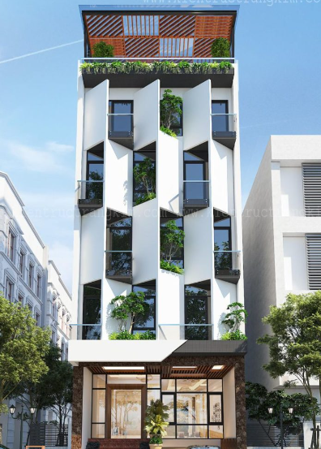
Figure 2. 10 Apartment
b) Home-Sharing and Room-Sharing.
Home-sharing and room-sharing platforms like Airbnb are becoming increasingly popular. With lower prices and a closer experience of local life, home and room sharing is an attractive alternative, challenging hotels' ability to provide personal experiences and private spaces traditional.
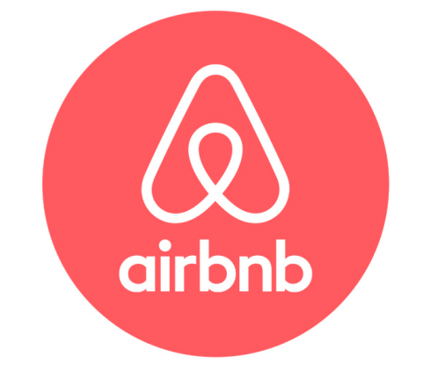
Figure 2. 11 Airbnb- Vacation rental company
c) Resort-Style Commercial Spaces.
The commercial resort gives a comprehensive resort experience, combining accommodation, shopping, dining, and entertainment in an integrated tourism space. With their utilization of local landscapes and diverse resort experiences, commercial resorts can be an attractive alternative for customers wanting to experience a variety of activities in one location.

Figure 2. 12 Resort

2.3 Competitive advantage.
The Prestige Imperial Hotel's price is slightly higher. However, it is worth the money with good service quality. The location in the center of Ho Chi Minh City (district 1) makes customers' travel more convenient. A smart room placement system helps avoid unoptimized room availability and ensures good profits for the hotel. The special thing here is that the hotel may not need a receptionist all day; it only needs service staff to ensure customers get the best service. Regarding payment, the hotel supports many different forms of payment but requires customers to reserve at least 50% of the service value in advance.

2.4 Competitive Strategy.
Based on the current situation, our business is not too big, but we are confident that our products are very unique, so we can confidently gradually become a big man. in the hotel industry by implementing a competitive strategy for the next 10 years as follows:
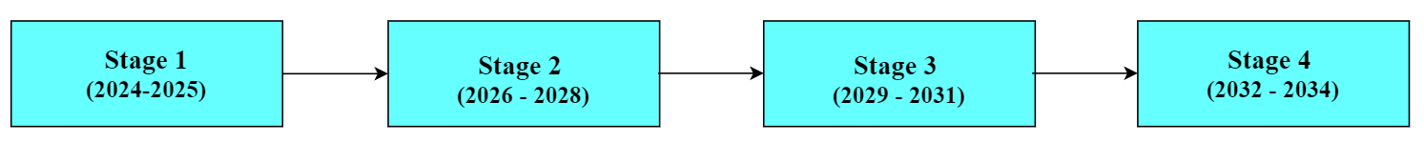
Figure 2. 13 Competitive strategy period in 10 years
a) Stage 1 (2024-2025): Focus on Strategy.
During the period from the first year (2024) to the end of the next year (2025), the organization will apply a focused strategy:
+ During this time, the organizer will design and test-run a few rooms according to the needs of domestic tourists and give guests feedback after each experience.
+ When collecting customer opinions and calculating which room types have the most bookings, the organization will apply that room's model to rooms that are not highly rated. At the same time, test the room booking scheduling system to optimize the number of rooms booked to bring in the highest revenue and efficiency.
+ This period will be spent upgrading and creating a place to serve as a base so that in the future, when developing other branches, there will be a place to use as a model.
b) Stage 2 (2026 - 2028): Product Differentiation Strategy.
From the beginning of 2026 to the end of 2028, the organization will apply a strategy of service differentiation, in which the organization will improve customer experience and innovate technology:
+ Improving customer experience, applying artificial intelligence and data to provide personalized experiences from the time customers book rooms, services and tailored to each customer's preferences.
+ Innovative technology to bring virtual reality tours for customers to explore before arriving at the hotel as well as augmented reality experiences in the hotel to enrich their experience. Besides, integrating IOT to automate utilities in the room slowly adjusts the light and temperature from the air conditioner.
c) Stage 3 (2029 - 2031): Product Differentiation Strategy.
From 2029 to 2031: after a period of brand building, the organization will begin to switch to a product differentiation strategy.
Signing contracts with businesses or tourism parties in order to get a solid number of customers during the year along with continuing marketing and improving the system to avoid falling behind the general level. Because the geographical location in District 1 and other provinces is not far away and convenient, proposing a contract with tourism companies and businesses can be considered.
d) Stage 4 (2032 - 2034): Product Differentiation Strategy.
From early 2032 to the end of 2034, the organization will apply an expansion and diversification strategy:
Open more branches and expand in neighboring areas, along with changing the decor in the room to have an environment that never gets old, making customers enjoy change but does not reduce service quality and costs.

2.5 Value Chain.

2.5.1 Main activities.
a) Inbound Logistics.
For this process, the business must contact a party with sufficient reputation and quality to place an order to keep the design of the product such as beds, mirrors, decor, and other items in the room from leaking design to the outside market. Along with that, the business will have to order a sufficient amount of backup to avoid situations where if the items are damaged, there will be other items to replace them immediately. The supplier can sign a long-term contract to make custom items in small quantities, which is appropriate. Along with that, there must be design samples of the rooms and other service areas of the hotel.

b) Operations.
For businesses, operations play an important role because the company's main goal is to provide rooms and accompanying services to individual customers or tours. The company needs to ensure that services are prepared cleanly and thoroughly while maintaining high hygiene and quality standards. One business process that the business will implement for this value chain activity is managing equipment and rooms, and monitoring market trends. Equipment must be checked regularly to avoid short circuits or damage.
c) Outbound Logistics.
Distribution activities, providing products and services to consumers. Activities can be storage, preservation of goods, distribution, and order processing, etc.
d) Marketing and sales.
This involves the activities necessary to promote, sell and increase reputation and service to customers. For businesses, Marketing and sales are very important because the company relies on mid-range customer segments and models to generate revenue and maintain its charitable mission. The company needs to maintain customer loyalty and attract new customers to continue growing. One business process that the business will implement for this value chain activity is to create targeted marketing and promotional campaigns, collect customer feedback, and analyze customer data for personalization, beautiful room service suggestions and improved customer experience.
e) Customer Service
After customers experience the business's services, they must collect opinions and reviews from customers to increase the online vote rate. If an unfortunate incident occurs while the customer is using it, they must be responsible for giving the voucher or handling it to avoid affecting the reputation of the business.

2.5.2 Support Activities.
a) Procurement.
Contact places that provide goods to ensure licenses, issue invoices, and ensure safety in quality and hygiene.
b) Technology development.
Actively applying technologies such as IoT to bring the most convenient services to customers, leading to innovations such as personalized customer experiences through smart room control and management Efficient resources with asset tracking.
c) Human resource management.
Develop criteria to select employees, and at the same time build and train to have an effective and luxurious working environment. Along with that, technical staff must be strictly placed within a certain time frame.
d) Firm infrastructure.
Customer rooms must always be kept at their best, and offices and warehouses must be in a clean condition, ensuring fire safety if an unfortunate event occurs. Along with that, equipment everywhere in the business needs to be maintained and upgraded according to schedule.

2.6 Information System.
a) Hardware.
Mainly computers are used to run programs related to work. Peripheral devices are used to store and input and output data. check-in, checkout equipment in hotels. Cameras monitor the hotel lobby and hallways. Disinfection and cleaning robot. Phones are filled in rooms and hotlines. Robot serving in the dining hall. Internet networks are used for data transmission. Water filtration equipment at the swimming pool.
b) Software.
Applications and websites for customers and employees. Invest in developing software used to control robot operations and camera monitoring software.
c) Human.
The user or customer is the person who directly uses the information system that the system creates. Information systems specialists build, operate, and maintain information systems. Marketing experts and accountants and lawyers take care of administrative work and legal documents.
d) Procedure.
Upon arrival, a 50% deposit is required for guests who book in advance through the app or web system. For customers who check in directly at the business, enter information on the machine at the service counter. The computer will save customer information and check basic issues such as age eligibility, then let the customer choose a room and record the time the customer stays and uses the room. Customers will enter additional service needs into the machine if needed, such as using the hotel's swimming pool or dining hall. After guests check out, use a robot to check the room and equipment, then proceed with cleaning the room.
e) Data.
Customer transaction data: Data includes information about customer reservations, payment details, and customer feedback. This data is relevant for businesses because it can be used to analyze customer behavior, personalize service recommendations, and improve customer experience. For example, by analyzing a customer's booking history, a business can identify popular room type choices and create targeted promotions to increase revenue.

CHAPTER 3: ORGANIZATION ISSUES.

3.1 Low-quality fire alarm system.
a) Existing problem.
Our hotel had serious problems with the hotel's fire alarm system. The current system is analog and has become outdated. Devices are connected using analog cables, leading to system crashes and reduced performance. Specifically, the problem lies with the device's reliability and resistance to measurement, which has become a concern.
In recent months, as we have attempted to operate the hotel, we have experienced multiple system failures, leading to costly downtime and unhappy customers. Furthermore, the lack of advanced technology has made it difficult for our team to effectively respond to emergencies. The lack of real-time data and remote monitoring capabilities has made it difficult to identify and resolve potential issues before they become major problems.
To solve this problem, we have planned to deploy a fire alarm system based on IOT technology. The system will be designed to meet the needs of the hotel, and will provide a high level of reliability, connectivity and management, ensuring a safe and high-performance environment for guests and staff.
b) Expectation.
The new system will include sensors and devices connected via the internet, allowing for seamless integration with other hotel equipment, such as security cameras and access control systems. This will enable real-time monitoring and reporting, allowing for quick and effective response in the event of an emergency.
With an IoT system, we will be able to monitor and manage alarm systems remotely, reducing the risk of errors and ensuring that our customers receive the best possible service.
Additionally, IoT systems will provide advanced analytics and reporting capabilities, allowing us to identify potential issues before they become major problems. This will allow us to quickly take corrective action, reduce downtime, and ensure that our hotels operate smoothly and efficiently.
IoT systems will also provide valuable insights into customer behavior and preferences, allowing us to tailor our services and amenities to meet their needs and improve the experience. their overall experience.
Furthermore, the IoT system will be designed to be scalable and flexible, allowing us to adapt to changing hotel needs and future technological advances. This will ensure that our fire alarm systems remain advanced and effective for many years to come.
c) Inducement.
The components affected the hotel's fire energy system.
- Data: Hotel energy usage data is not monitored and tracked in real time, making it difficult to identify energy waste and optimize energy use. Hotel energy data is not thoroughly analyzed, making it difficult to identify trends and patterns in energy use and prevent energy waste.
- Hardware: The hotel's energy system is based on outdated equipment and technology, operates inefficiently, and is prone to incidents. Inadequate hotel energy storage capacity leads to frequent energy waste and high electricity bills.
- Software: The hotel's energy management system was outdated and did not provide real-time monitoring and control, making it difficult to optimize energy use and prevent energy waste.
- Process: The hotel's electrical system is not properly maintained, leading to equipment damage and energy waste. Guest energy usage patterns are not optimized, leading to energy waste and high energy bills.
- Human: Hotel staff are not trained on energy efficiency and conservation measures, leading to inefficient energy use and energy waste. Lack of communication between hotel staff and departments leads to lack of coordination and planning for energy savings and efficiency.

3.2 Website not yet developed.
a) Existing problem.
We also know that without a website, it will reduce access to potential customers in the online environment, making it difficult for customers to find information and make reservations.
Currently, all hotel booking procedures can only be booked directly through the hotel receptionist or hotline number, which puts customers at a disadvantage as they will not know the room they want to book. Is it there or not?
b) Expectation.
Create a professional website for the hotel, providing detailed information, images, services, and online booking functions. To give customers more convenience and easier access to the hotel. From there, it helps promote hotel development.
We hope to create a smart room control system based on IoT technology. This innovative system uses sensors and devices connected to the Internet to control and monitor various aspects of the room, including lighting, temperature, and electronics. With a smart room control system, guests can adjust these settings through the mobile app or web interface, providing a seamless and comfortable experience.
In addition, IoT technology can also be applied to facility management, allowing real-time monitoring and management of various systems and devices in hotels, such as air conditioners, security sensors, and more. security and energy efficiency data. This helps improve operational efficiency, reduce operating costs and improve the overall guest experience.
c) Inducement.
- Hardware & Software: Using old hardware and outdated software systems cannot meet modern website management and deployment requirements. Lack of knowledge or resources to implement new technologies such as responsive design, SEO optimization, or online booking system.
- Data: There is not enough necessary data about customers, markets, and needs to build an effective website that meets customer expectations. Data is not updated regularly or is not synchronized between internal systems, causing difficulties in organization and presentation on the website.
- Process: Lack of long-term strategy in applying technology for online business promotion and development. Website development is not considered a priority because the current operational process focuses on other aspects of the business.

3.3 Energy wastage.
a) Existing problem.
Hotels are facing wasteful energy consumption due to a lack of ability to effectively monitor and manage electricity consumption. The air conditioning and lighting systems operate continuously without control, with electrical equipment being used without a clear plan. This leads to increased operating costs and a negative impact on the environment.
In addition, the energy system is also based on outdated equipment and technology, so it operates inefficiently and is prone to incidents.
b) Expectation.
The Internet of Energy application will help the hotel system optimize management and save energy more effectively. From automatically adjusting temperature and lighting to managing the use of smart electrical devices, the system will help reduce waste and improve customer experience. At the same time, through monitoring, analyzing, and reporting on energy consumption, the system will support hotels in building a sustainable and environmentally friendly image.
c) Inducement.
The components affected the hotel's fire energy system.
- Data: Hotel energy usage data is not monitored and tracked in real time, making it difficult to identify energy waste and optimize energy use. Hotel energy data is not thoroughly analyzed, making it difficult to identify trends and patterns in energy use and prevent energy waste.
- Hardware: The hotel's energy system is based on outdated equipment and technology, operates inefficiently, and is prone to incidents. Inadequate hotel energy storage capacity leads to frequent energy waste and high electricity bills.
- Software: The hotel's energy management system was outdated and did not provide real-time monitoring and control, making it difficult to optimize energy use and prevent energy waste.
- Process: The hotel's electrical system is not properly maintained, leading to equipment damage and energy waste. Guest energy usage patterns are not optimized, leading to energy waste and high energy bills.
- Human: Hotel staff are not trained on energy efficiency and conservation measures, leading to inefficient energy use and energy waste. Lack of communication between hotel staff and departments leads to lack of coordination and planning for energy savings and efficiency.

CHAPTER 4: PROPOSAL OF A NEW SYSTEM.

4.1 Use case diagrams.
a) Fire Alarm systems.
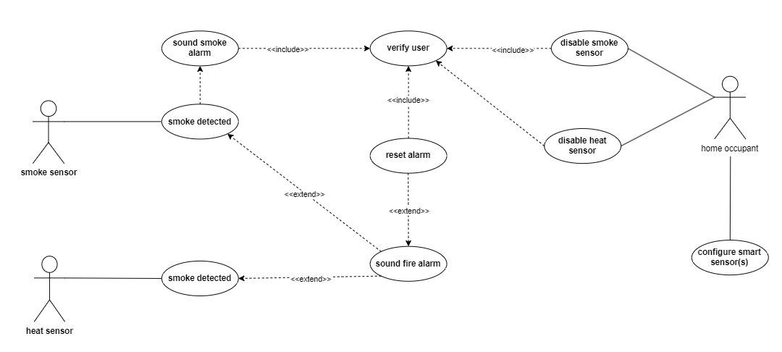
Figure 4. 1 Use case diagrams of fire alarm systems.
b) Hotel Website.
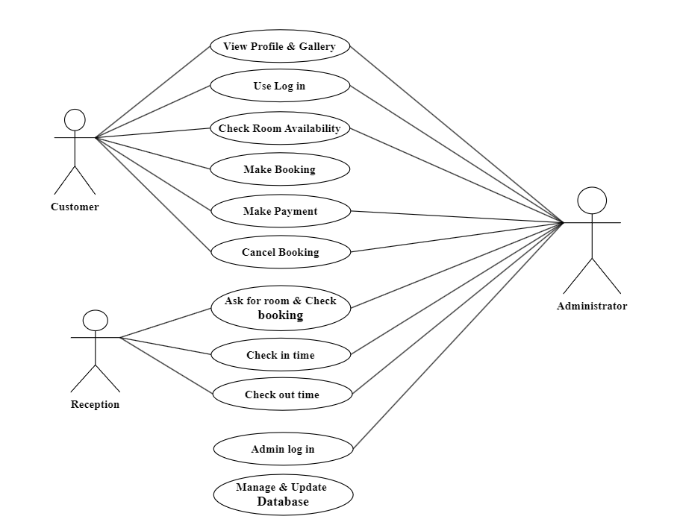
Figure 4. 2 Use case diagrams of hotel website
c) Energy System.
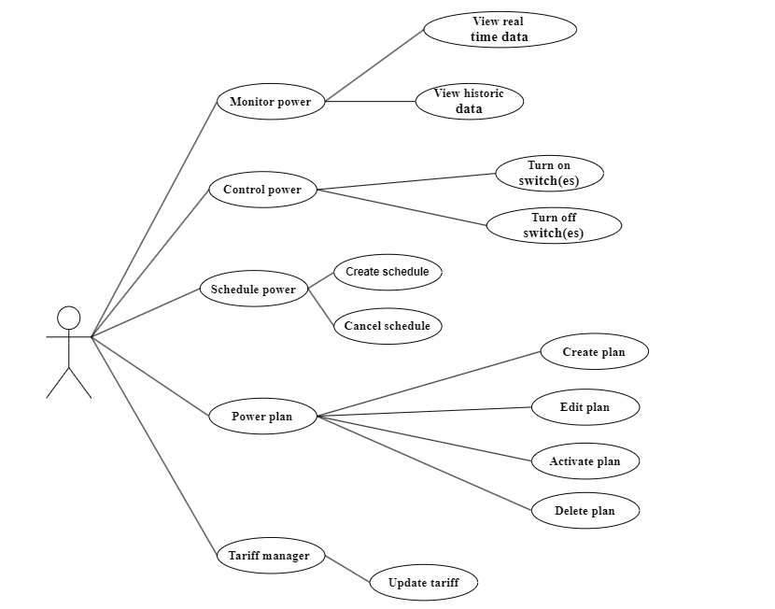
Figure 4. 3 Use case diagram of energy systems

4.2 ERD.

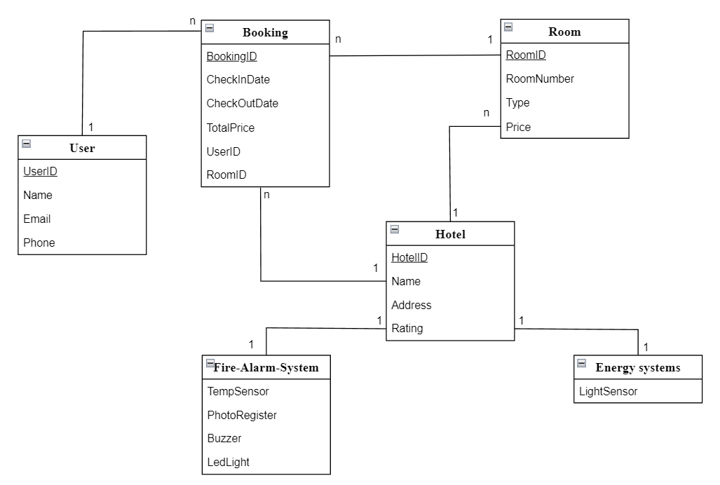
Figure 4. 4 ERD of Hotel

4.3 Improved technique.
a) Fire Alarm systems.
In terms of implementation, integrating fire alarm systems and IoT typically involves the use of sensors and other devices connected to the Internet. These devices communicate with the central control system, which manages the fire alarm system and other connected devices. The central control system can be accessed remotely via a web-based interface or mobile app, making it easy for building managers or owners to view data to help keep their lives safe.
IoT integration can provide real-time monitoring and centralized management of fire alarm systems. This connectivity and accessibility enable proactive maintenance, effective troubleshooting, and timely decision-making.
IoT can use a single host device (e.g., a phone or computer interface) to bring together data from different alarm systems, allowing users to quickly view logs and maintenance data. By accurately sensing the location of the fire, its nature, and whether there is anyone in the room, IoT-enabled smart fire systems can deploy different measures for specific rooms, minimizing damage to the wider facility. New and smart systems can integrate information from almost any type of fire alarm system via the internet, so the information can be viewed on a mobile phone, laptop, or tablet from everywhere in the world. This data can also be used for compliance purposes and to demonstrate that the person responsible has done everything possible to ensure the building is safe.
b) Hotel website.
To develop websites through IoT (Internet of Things), this technology can be applied to create an interactive and convenient online experience for users. By connecting smart devices to the website, users can interact with services and information on the website more flexibly and intelligently.
For example, IoT can be used in the travel industry to provide live information about traffic conditions, weather, schedules or the status of services such as hotel rooms, tours, airline tickets, etc. through internet-connected devices. This helps improve user experience, increase interactivity and utility of the website.
In addition, IoT can also be applied in data management and customer feedback. IoT sensors can help automatically collect and analyze data from users on the website, thereby providing more personalized insights and recommendations, helping to improve marketing efficiency and increase engagement. with customers.
c) Energy systems.
Besides providing timely support in situations to improvise during a fire, Introducing IoT technology into management will help save a fair amount of energy. By connecting devices and sensors to the internet, we can monitor and adjust energy consumption in a smart and effective way.
Typically, IoT is used to automatically turn off devices when they are not in use, as well as set up smart operating times to optimize energy. Thanks to that, by combining technology and electricity-saving awareness, people can indirectly reduce energy waste globally and actively contribute to environmental protection.
Besides, we can create an automatic recovery grid system in case of power leakage. When a problem occurs, the system will automatically identify the error, damaged wire segments and then redirect the power source. This overcomes the situation of waiting for qualified experts to arrive to handle the problem and avoids wasting electricity and leaking electricity affecting the human living environment.

4.4 Analyze the improvement.
Ordinal number | New proposals | Describe | Compatibility
1 | Automatically notify users | When a problem occurs, the system can send an alert to the mobile phone of the manager or customer in the hotel. | 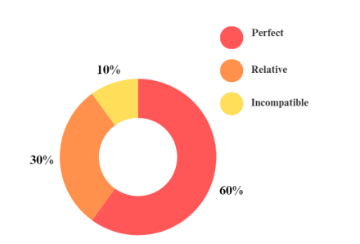
2 | Remote control for fire alarm system | The ability to remotely activate or deactivate the fire alarm system via a phone application helps manage incidents quickly and effectively. | 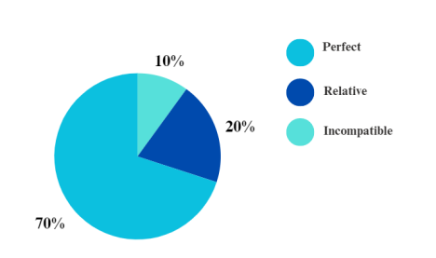
Ordinal number | New proposals | Describe | Compatibility
3 | Record data and statistics | IoT system applications can record data about fire alarm events, helping with later analysis and system improvement. | 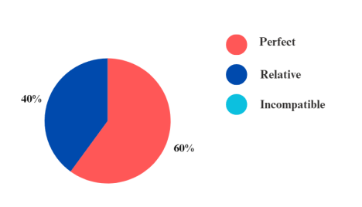
4 | Install smart sensors | Use sensors to measure the energy consumption of electrical equipment and systems in hotels. | 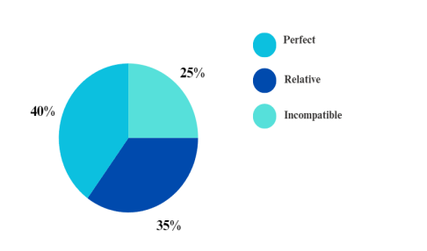
5 | Integrate app for management | Use an app to allow hotel management to remotely monitor and control energy usage via mobile or desktop applications. | 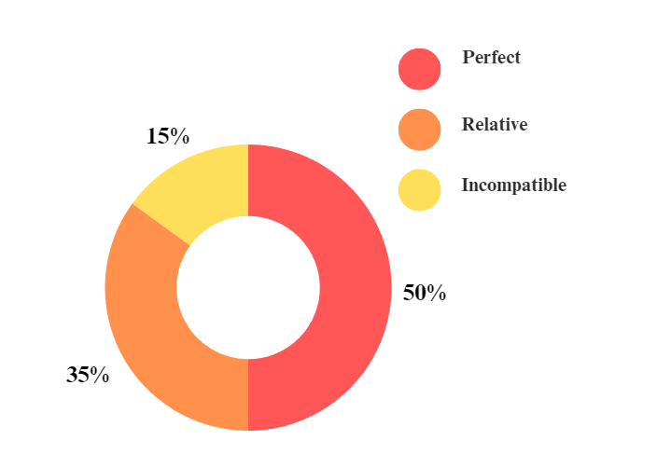
6 | Integrated smart online support system | Use chatbots or virtual assistants based on IoT technology to provide instant support to users, helping them find information more quickly and easily. | 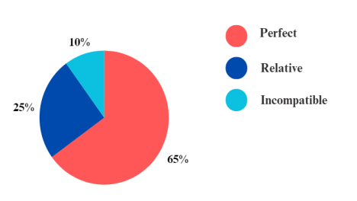
Ordinal number | New proposals | Describe | Compatibility
7 | Monitor and optimize user experience | Use IoT technology to collect data about how users interact with the website. Based on this information, you can optimize user experience, improve page load speed, and provide more personalized content. | 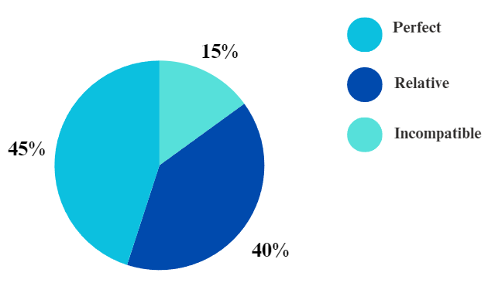
Table 4. 1 Table of the improvement

4.5 Identify ethical and privacy issues.
In implementing IoT systems into hotel fire alarms and energy systems, identifying and addressing ethical and privacy issues is important. Some points to note include:
First, protecting personal data is a top priority. Data collected from IoT sensors may contain personal information about customers and employees, so it is necessary to ensure that data is protected securely, and that personal information is not illegally disclosed.
Second, data acceptance is necessary. Before collecting data, there needs to be clear acceptance and consent from users about the purpose of using the data as well as protecting their data.
Third, there needs to be transparency and clarity about the security and privacy policies. Users need to be fully informed about the collection, storage, and use of their data.
Fourth, ensuring data safety and security is essential. Data collected from IoT devices needs to be strictly protected to avoid issues related to cybersecurity and external attacks.
Finally, the data needs to be up to date and accurate. This helps ensure that the system operates efficiently and reliably in energy management and ensures the safety of guests and staff in the hotel.

CHAPTER 5: DEMO.

5.1 Website.
This is the main interface of the website when visitors access it, with a booking function and information for each room type:
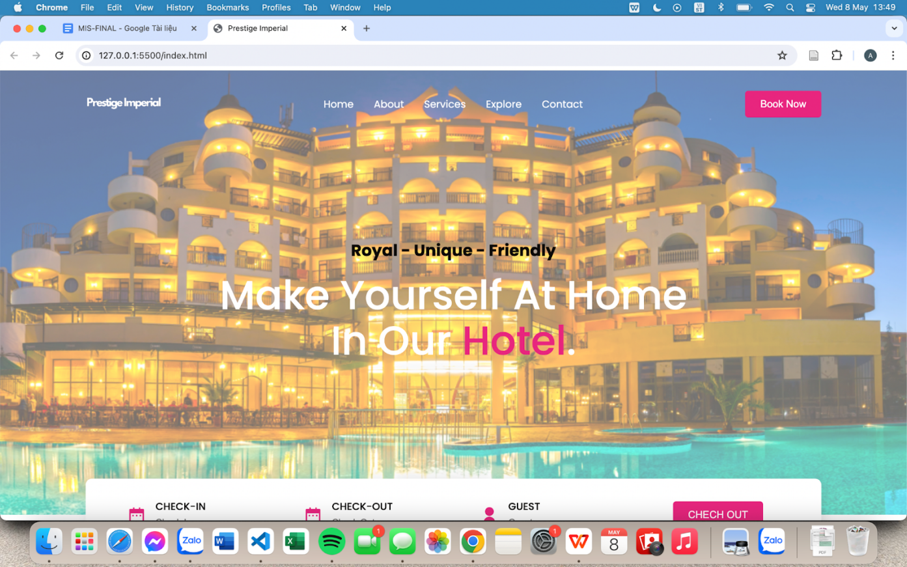

Figure 5. 1 Interface of hotel website

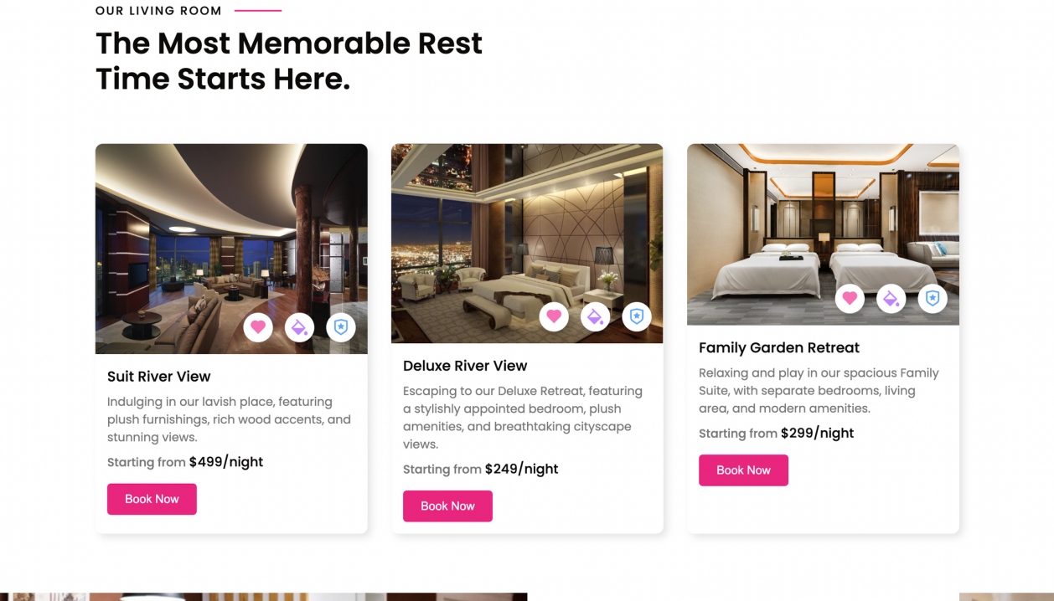
Figure 5. 2 Interface of booking hotels website

5.2 Fire alarm system.
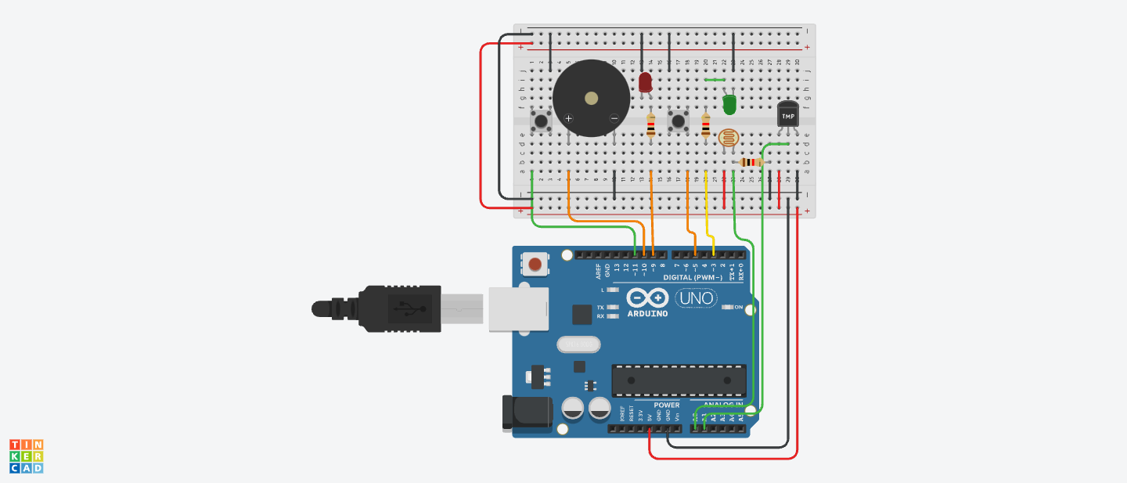
Figure 5. 3 Fire alarm system
5.3 Booking directly.
Also, don't worry too much if you are not good with technology or are afraid of leaking your personal information to outside parties when booking online. Prestige Imperial will have a direct booking area to help customers avoid the above situations or handle situations where unexpected trips occur, and customers have not had time to book a hotel room.

CHAPTER 6: EVALUATION, CONCLUSION.

6.1 Pros and Cons.
a) Pros
Integrating IoT technology into hotels brings many significant benefits. First, IoT enables the automation of operations such as lighting, temperature and room service controls, enhancing customer convenience and comfort. This system also supports effective information management. By collecting and analyzing data from devices, hotels have an overview of operations and can make decisions based on accurate information. This also contributes to energy savings through automatically adjusting the energy use of devices such as lights and air conditioning, reducing energy consumption and associated costs.
Not only that, IoT also helps improve customer experience through personalized service. Based on customer data and requests, hotels can provide appropriate services, improving service quality and their experience.
Finally, integrating IoT technology also brings security and privacy benefits. With sensors and surveillance cameras, IoT provides a comprehensive security solution, helping to protect property and ensure the safety of hotel customers and employees.
b) Cons
Deploying IoT systems in hotels brings many benefits but also comes with some challenges and risks. First is the initial investment cost. Implementing this system requires a large investment in purchasing and installing equipment, as well as training staff to use and manage the system. The next challenge is security. When connecting multiple devices and data online, the possibility of cyber-attacks and information security risks increases, especially when proper security measures are not in place.

In addition, hotels also face dependence on technology. If the system experiences technical problems, such as power outages, software errors or connectivity issues, the hotel's ability to operate can be severely impacted, impacting customer experience and business operations. of the hotel.

6.2 Our Reviews.
Applying IoT technology in the hotel system is a significant step forward, helping to optimize operations and improve customer experience. However, to ensure success, system implementation and management need to be done carefully and effectively.
With the rapid development of technology and increasing demands from customers for experience and convenience, applying IoT in the hotel system is not only a trend but also an important factor for competition and development. However, this also requires hotels to invest not only financially but also in knowledge and resources to effectively manage and protect the system.

6.3 Lessons learned from the project.
Participating in a consulting project and building a smart information system in the field of Enterprise Information Management (MIS) requires us to learn important lessons:
- First, understanding the needs and goals of the organization is a core factor, which helps us determine an information system design strategy that is appropriate and maximally supports the business goals of the organization. organization.
- Second, close interaction and cooperation with customers is indispensable. Must listen and receive opinions and requests from customers to be able to provide the optimal and most suitable solution.
- Third, we need to pay attention to data and information analysis. In the MIS field, this capability helps us make smart decisions and optimize organizational operations.
- Fourth, continuous testing and evaluation of intelligent information systems is also extremely important. This helps us ensure the system always meets requirements and brings real value to the business.

-Finally, with the rapid pace of development in the MIS field, staying up to date with new technology and cutting-edge trends is a must. This helps us improve the efficiency and competitiveness of information systems, while ensuring the organization does not become outdated in technology.

6.4 Evaluate group activities.
Student ID | Name | Task | Percentage
521H0285 | Phạm Trần Tiến Phát | - Describe your business.  - Strategy.  - Information structure.  - Existing problems.  - Source code.  - Presentation. | 100%
521H0218 | Phan Thành Đạt | - Usecase Diagram.  - ERD.  - Improvements.  - Analyze the improvements.  - Source code. | 100%
521H0004 | Lê Minh Anh | - Industry structure.  - Value chain.  - Inducement.  - Identify ethical and privacy issues.  - Evaluation, conclusion.  - Source code. | 100%

CHAPTER 7: SELF - EVALUATION FORM
Request | Description | Score
Describe your business (0.5pts) | Visualize the fictional company in detail using professional techniques. | 0.5
Analyze the current state (2pt)
Industry structure (0.5pts) | The analysis utilizes real data, providing a clear industry structure overview and effectively applies Porter's Five Forces model. | 0.5
Strategy (0.5pts) | Identify and explain the company's competitive strategy, its pros and cons, and the link to industry structure. | 0.5
Value chain (0.5pts) | Identify and describe the critical activities within the company's value chain. | 0.5
Information structure (0.5pts) | Describe the components of the current information system vividly and comprehensively using visual aids. | 0.5
Organizational issues (1 pt)
Existing problems (0.25pts) | Identify multiple issues with the current system and outline the desired objectives of the new system along with a rationale. | 0.25
Inducement (0.75pts) | Identify multiple issues with the old system and outline the desired objectives of the new system along with a rationale. | 0.75
Proposal of a new system (2.5pts)
Usecase Diagram (0.5pts) | Write Use Case Diagram is thorough and well-defined, with clear functions. The specifications are complete, easy to grasp, and concise. | 0.5
ERD (0.5pts) | Write accurate and easy-to-understand Entity Relationship Diagrams (ERDs). The specifications are comprehensive, simple and concise. | 0.5
Improvements (0.25pts) | Describe over three key new features that effectively address the issues of the old system in a concise manner. | 0.25
Analyze the improvements (0.25pts) | Thoughtfully evaluate and provide logical explanations for proposals that influence the organization's competitive strategy. | 0.25
Identify ethical and privacy issues (0.5pts) | Identify multiple issues and offer a reasonable explanation for each. | 0.5
Evaluation, conclusion (0.5pts) | Ensure that the conclusions and judgments are clear, reasonable, and concise. Explain the alignment of the proposed system with the identified problems in a straightforward manner. | 0.5
Total |  | 6.0

REFERENCES
- Koorsen Fire & Security. "How is Fire Alarm Technology Advancing to Enhance Fire Safety." Koorsen Blog, https://blog.koorsen.com/how-is-fire-alarm-technology-advancing-to-enhance-fire-safety (Accessed: May 10, 2024).
- Aeris. "How the Internet of Things (IoT) is Changing Fire Safety." Aeris Resources, https://www.aeris.com/resources/how-the-internet-of-things-iot-is-changing-fire-safety/ (Accessed: May 10, 2024).
- Chint Global. "Ứng dụng IoT trong hệ thống năng lượng." Chint Global Vietnam, https://chintglobal.vn/ung-dung-iot-trong-he-thong-nang-luong/ (Accessed: May 10, 2024).

